Project Database Design

## **Views:-**

1. Simple View
   1. A view should have only single table select statement
2. Complex View
   1. A view should have more than one table select statement it means it suppose to be Join query

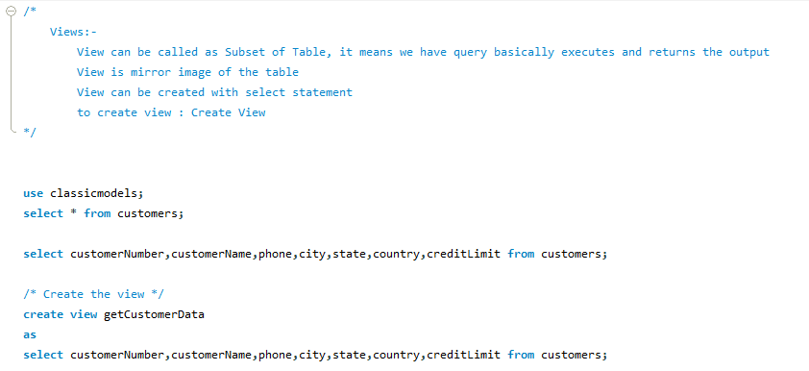

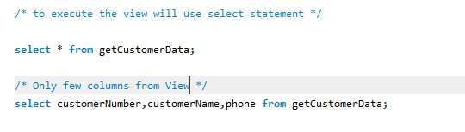

The record is not inserting here:



A view can be updated under certain conditions which are given below −

* The SELECT clause may not contain the keyword DISTINCT.
* The SELECT clause may not contain summary functions.
* The SELECT clause may not contain set functions.
* The SELECT clause may not contain set operators.
* The SELECT clause may not contain an ORDER BY clause.
* The FROM clause may not contain multiple tables.
* The WHERE clause may not contain subqueries.
* The query may not contain GROUP BY or HAVING.
* Calculated columns may not be updated.
* All NOT NULL columns from the base table must be included in the view in order for the INSERT query to function.

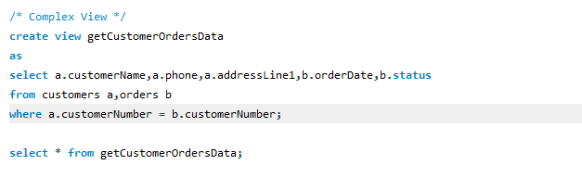

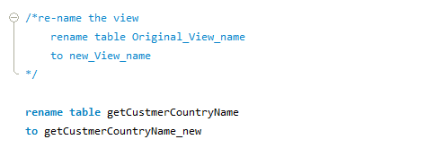

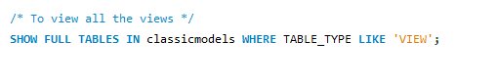

Table Rename:

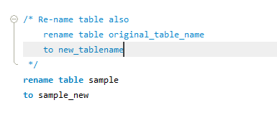

Table Alter :

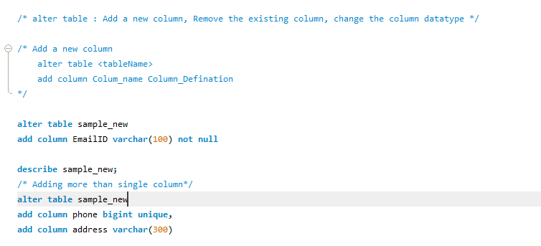

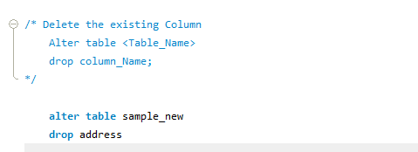

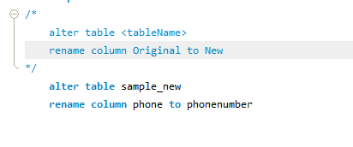

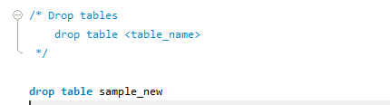

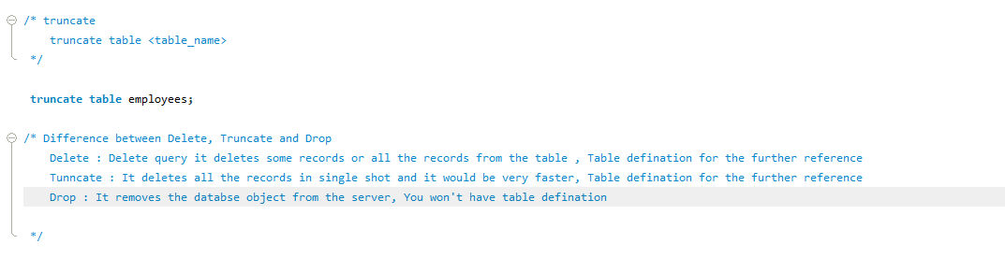

Node.js Introduction

1. Node.js is an open source server side technology
2. Node.js it works on different platforms like windows,Linux,Unix,Mac
3. Node.js uses javascript on the server
4. Node.js can generate the dynamic page content
5. Node.js create,delete,read,write
6. Node.js can collect form data (Registration Page)
7. Node.js modification of database it supports

Let’s Get starts with Node.js

1. Download from <https://nodejs.org/en/>
2. Install on your computer